Department of Scientific Computing, Modeling &Simulation

Savitribai Phule Pune University, Pune 411007

Scientific Computing Department

* Student Names : 1. Dipak Bharade (MS2103)

2. Manthan Chougule (MS2105)

3. Jayesh Jadhav (MS2109)

4. Gaurav Murumkar (MS2111)

* Class : M.Sc. (Scientific Computing) – I
* Project Guide : Mr. Ichchhayakant Sharma
* Project Name : E-Auction Pune

**YEAR 2022-2023**

**SPPU’s**

Department of Scientific Computing, Modeling &Simulation

Savitribai Phule Pune University, Pune 411007

Department of Scientific Computing

**M.Sc. Scientific Computing-I, Sem-II 2021-22**

***CERTIFICATE***

This is to certify that Mr. / Miss.

Roll No. Has successfully completed the Project entitled

As part of the M.Sc. (Computer Science)-I curriculum during the academic year 2021

- 2022

|  |  |  |
| --- | --- | --- |
| Date: |  | |
| Project Guide: Mr. Ichchayakant Sharma |  | Head of Department of Scientific Computing |
| Examiners: Names |  | Sign |

1. Dipak Bharade (MS2103)

2. Manthan Chougule (MS2105)

3. Jayesh Jadhav (MS2109)

4. Gaurav Murumkar (MS2111)

ONLINE AUCTION SYSTEM

PROJECT REPORT

# INDEX

1. About the project
2. Problem Definition
3. Existing System and need for the new system
4. Scope of the work
5. Feasibility study
6. Requirement Analysis
7. E-R diagrams
8. Decision trees/Decision tables
9. Normalized Database Design & Data Dictionary.
10. Use-case Diagrams
11. Class Diagrams
12. Object Diagrams
13. Sequence Diagrams
14. Activity Diagram
15. State Chart
16. Drawbacks, Limitations & Proposed enhancement
17. User interface design Menus
18. Bibliography/Reference

# ABOUT THE PROJECT

“eAuction Pune” is an online auction web site aimed at taking the auction to the fingertips of aspiring bidders there by opening up the doors of the “OPEN Auction House’’ to a wider cross section of Art Lovers and Antique Collectors and many more. This site also acts as an open forum where buyers and sellers can come together and exchange their products. The site makes sure that the sellers get a fair deal and buyers get a genuine product.

Home Page - The site opens up door to aspiring web users through the Home page. The Home page is designed in such way that the layout is as user friendly as possible. There is a navigational menu at the top of the page which links to various inner pages. There is a category drop down on the left side for easy manipulation. The center area is for displaying latest products in the chorological order.

Login/User Registration - Those who wish to take part in bidding or sell products at the site have to register at the

Site as seller or buyer. Only authenticated users can take part in selling or in bidding.

Register Products - This module is for presenting items for bidding. Only those who have registered and authenticated as sellers can place their articles for bidding. The Module collects information like Product Name, Product Details, Highest Bid amount, etc.

Bidding Module - The module is for bidding on any selected item. The bidder has to authenticate before participating in bidding. The system checks whether the incremental amount entered by the bidder is equal or more than the incremental minimum set during the product registration time.

# PROBLEM DEFINITION

The problem with public auction is that the participation of the general public is very limited. The aim of the project is to socialize the auction so that people from far & wide and even across the continent can participate in it. The “E Auction" site is developed with a vision to wipe out the inherent problems of "Conventional Auction House". The salient features of the site are as follows:

* Paperless Auction System.
* It's accessible to everyone, at any time no matter where they are.
* Reliable user validation & checking.
* Easy online settlement.

# EXISTING SYSTEM

The existing "OPEN Auction House" is managed manually. Prior to each auction, the day of auction, the venue and the items on auction are announced through news media.

Those who wish to take part in the auction have to arrive at the venue on that day on time.

This conventional method most of the times prevent aspiring bidders from participating in the bidding process. Another headache of the old system is to track each bidding process.

So the system has to keep records of both buyers and sellers until the end of settlement. The process is very cumbersome and time consuming.

# PROPOSED SYSTEM

The “e-Auction" is online auction house so the seller or bidder doesn't need to go anywhere, instead they can take part in the auction just sitting in the comfort of their living room.

The proposed computerized “e-Auction" site has made auction process simple. The user must register and authenticate before he/she can take part in the bidding process.

Another important module in the proposed project is the "Bidding module ". Here one can see the details of any particular product and also the closed listing.

The user can bid on that item by entering any amount greater than or equal to the incremental bid amount. Here also system checks to see whether the user has his credential verified otherwise he/she will be directed to the login/registration page.

# SCOPE OF THE SYSTEM

This system is designed as an online web-based application which shall be accessed by any device, either a computer, tablet, iPad, iPhone, mobile phone.

Using this online auction management system, bidders will be able to get connected to the specific sellers who will offer them necessary information and give hand to sell their items to them. It will help to save time and offer quality deliverables to the bidders by quick response and attention services . This system will replace the manual way of seeking items in the market and travelling long journeys just to get an item.

The scope of this application to build a user friendly auctioning website, where user will be able to auctioned any product which is available anywhere in the world. By using Online Auction management system it will be easy for auctioneer to make an auction and time saving also. By making auction through this application will help to reach maximum of buyers bidding in local area. There will be a feature where bidder and seller can message each other.

# Future Scope of the Project

1. Content-based Recommender System

* Priority : For All Users (Public)

Recommender systems are methods that predict users’ interests and make meaningful recommendations to them for different items, such as songs to play on Spotify, movies to watch on Netflix, news to read about your favorite newspaper website or products to purchase on Amazon.

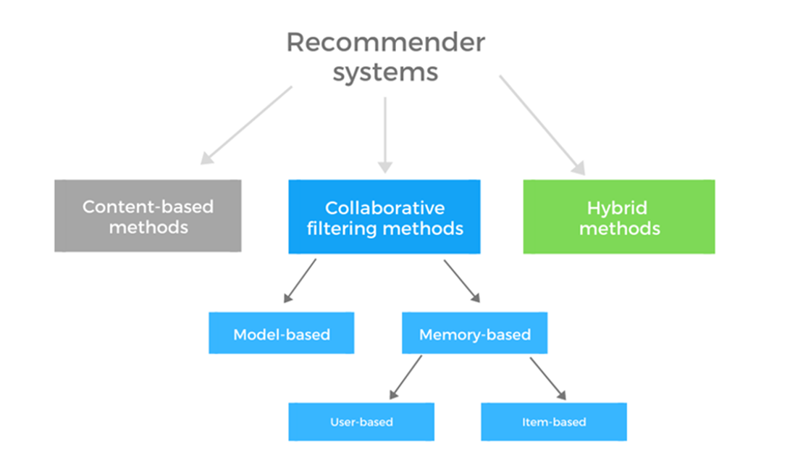

# Future Scope of the Project

2. Price Prediction Model

* Priority : Only for Admin Access (Private)

Recommender systems are methods that predict users’ interests and make meaningful recommendations to them for different items, such as songs to play on Spotify, movies to watch on Netflix, news to read about your favorite newspaper website or products to purchase on Amazon.

# FEASIBILITY STUDY

Operational Feasibility

An estimate should be made to determine how much effort and care will go into the developing of the system including the training to be given to the user. Usually, people are reluctant to changes that come in their progression. The computer initialization will certainly affected the turn over, transfer and employee job status.

Hence an additional effort is to be made to train and educate the users on the new way of the system.

Technical Feasibility

The main consideration is to be given to the study of available resources of the organization where the software is to be implemented. The system analyst evaluates the technical merits of the system giving emphasis on the performance, reliability, maintainability and productivity. By taking the consideration before developing the proposed system, the resource availability of the organization was studied. The organization IS equipped with sophisticated machines and the software.

Economical Feasibility

Economic feasibility is the most important and frequently used method for evaluating the effectiveness of the proposed system. It is very essential because the main goal of the proposed system is to have economically better result along with increased efficiency.

Cost benefit analysis is usually performed for this purpose. Since the organization is well equipped with the required hard ware, the project was found to be economical.

# REQUIREMENT ANALYSIS

The primary goal of the system analyst is to understand the requirements of the new system that is to be developed.

For that the study of specification of the requirements is very essential. For the development of the new system, a preliminary survey of the existing system will be conducted. Investigation is done whether the upgradation of the system into an application program could solve the problems and eradicate the inefficiency of the existing system.

Hardware Requirements: - 500MB RAM and above, 1.5GHz Processor speed, 100MB of free disk space

Software Requirements: - Linux / Windows / Mac / Android, Web Browser, PostgreSQL, Python-Django

# ER DIAGRAM

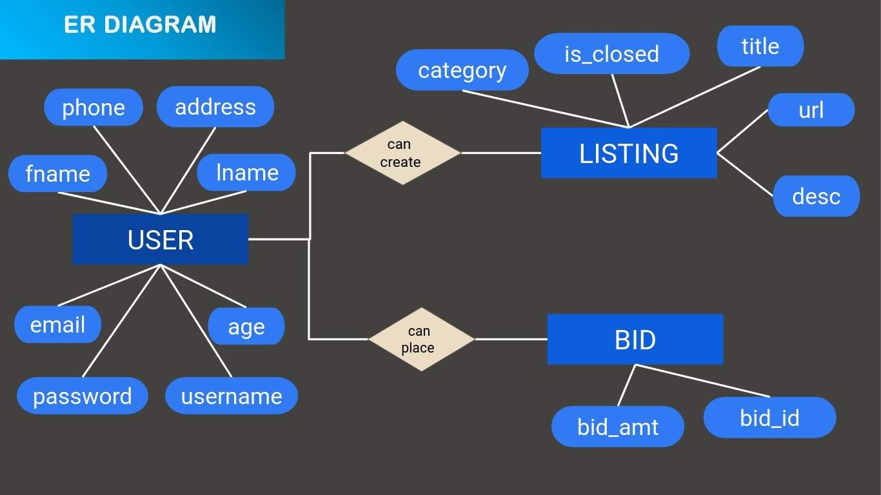

NORMALIZED DATABASE DESIGN

**Table Name: User**

|  |  |  |  |  |
| --- | --- | --- | --- | --- |
| **Fields** | **Type** | **Null** | **Key** | **Default** |
| **user_id** | int | NO | primary | 0 |
| **username** | char | NO | unique |  |
| **fname** | char | NO |  |  |
| **lname** | char | NO |  |  |
| **email** | char | NO | unique |  |
| **phone** | int | NO |  |  |
| **address** | char | NO |  |  |
| **age** | int | No |  |  |
| **gender** | char | NO |  |  |

**Table Name: Bid**

|  |  |  |  |  |
| --- | --- | --- | --- | --- |
| **Fields** | **Type** | **Null** | **Key** | **Default** |
| **bid_id** | int | NO | primary | 0 |
| **bid_amt** | int | NO |  | 0 |
| **user_id** |  | NO | foreign |  |

**Table Name: Listings**

|  |  |  |  |  |
| --- | --- | --- | --- | --- |
| **Fields** | **Type** | **Null** | **Key** | **Default** |
| **listing_id** | int | NO | primary | 0 |
| **title** | char | NO |  |  |
| **is_closed** | bool | Yes |  | false |
| **description** | char | NO |  |  |
| **url** | char | NO |  | tree.jpg |
| **category** | char | NO |  |  |
| **bid_id** | int | NO | foreign |  |
| **user_id** | int | NO | foreign |  |

**Table Name: Listing_watchlist**

|  |  |  |  |  |
| --- | --- | --- | --- | --- |
| **Fields** | **Type** | **Null** | **Key** | **Default** |
| lw_id | int | NO | primary | 0 |
| bid_id | int | NO | foreign |  |

# USE-CASE DIAGRAM

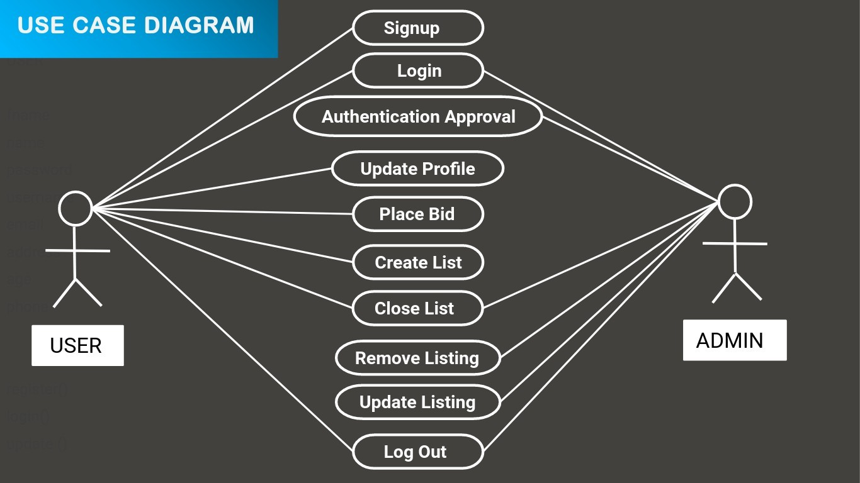

CLASS DIAGRAM

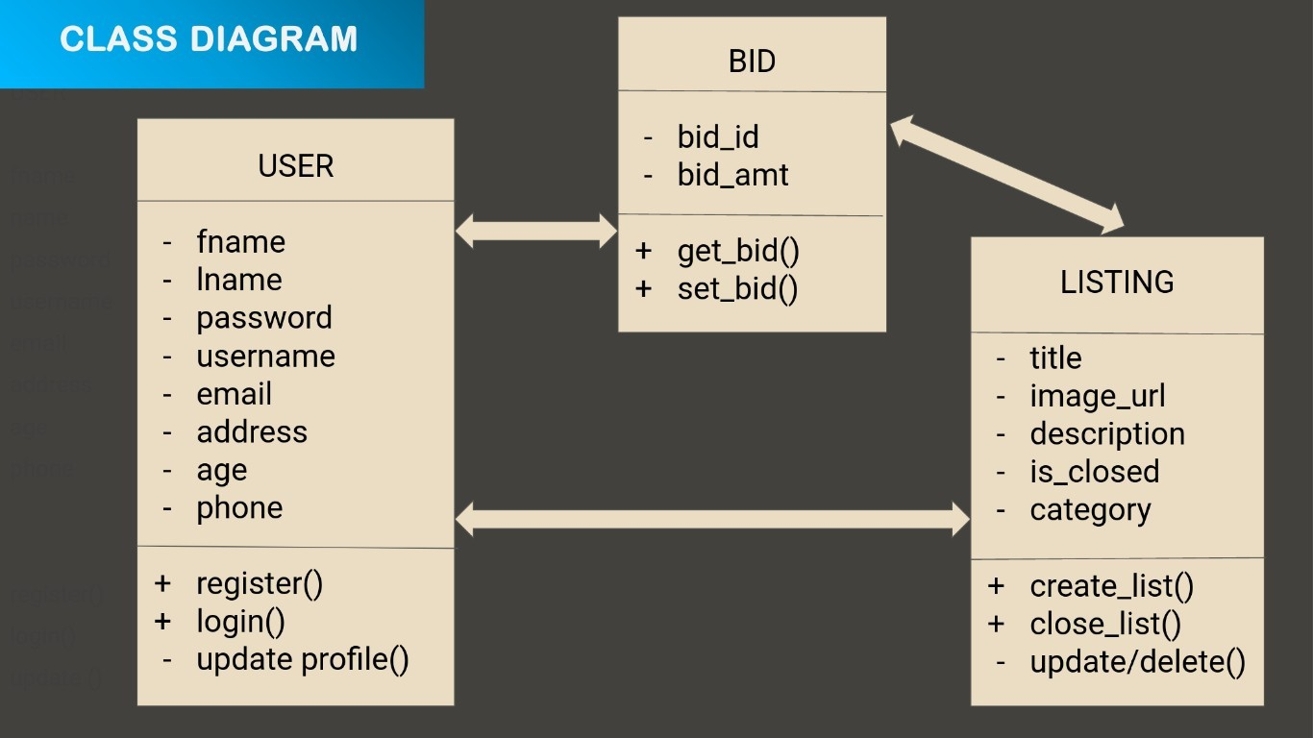

# OBJECT DIAGRAM

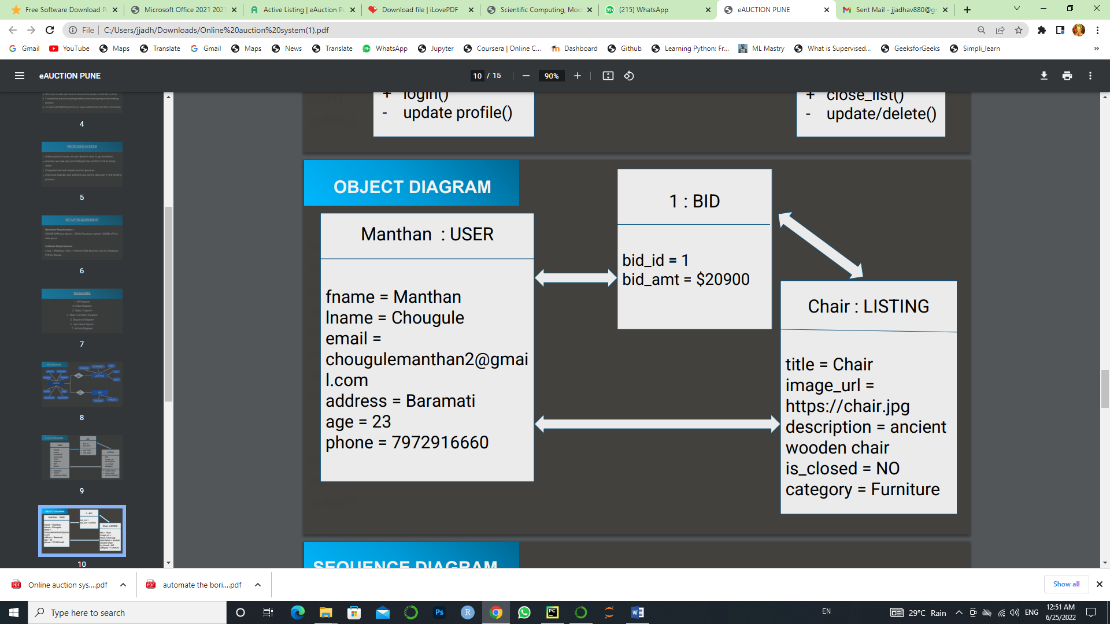

SEQUENCE DIAGRAM

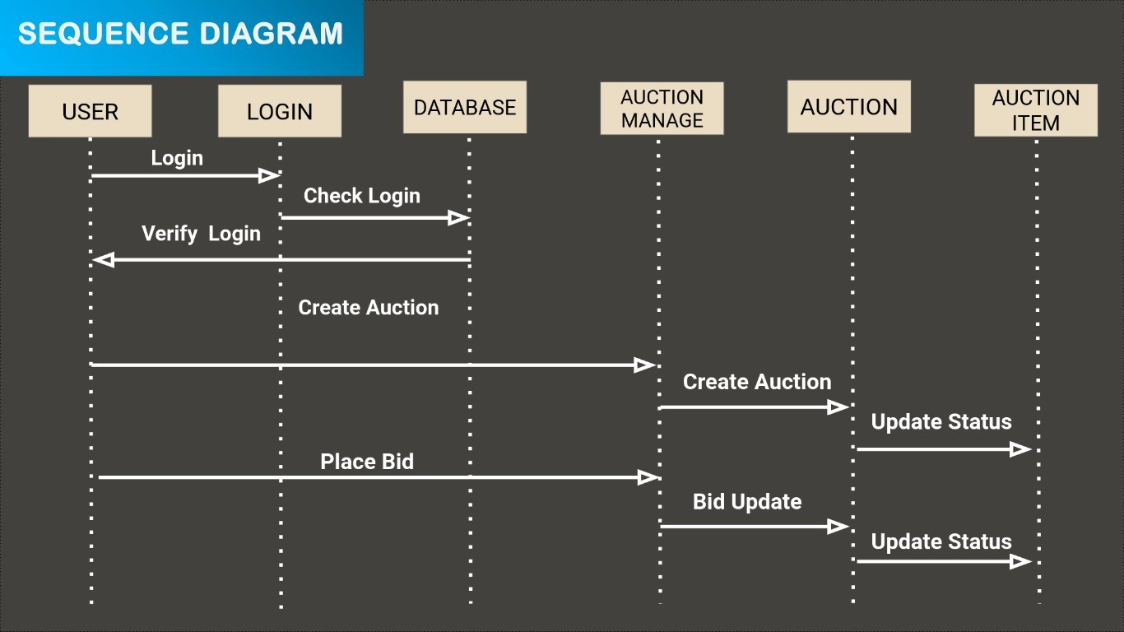

# ACTIVITY DIAGRAM

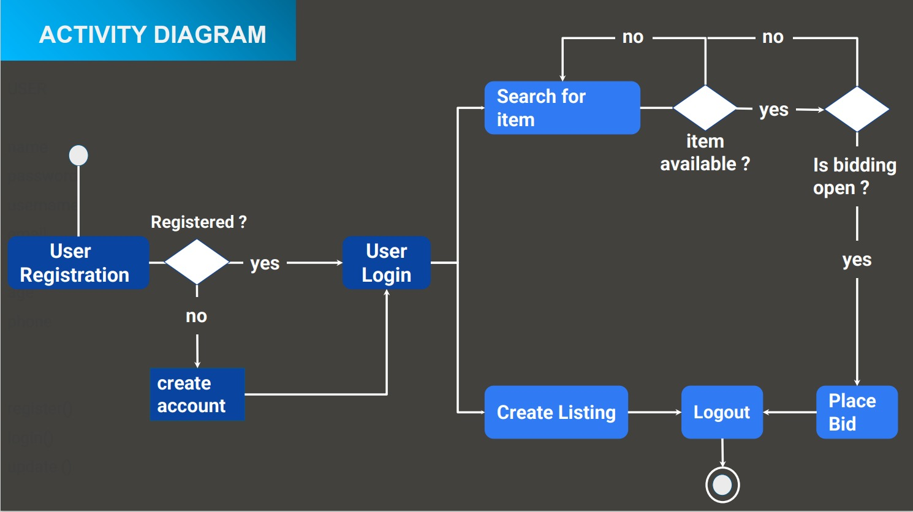

STATE CHART DIAGRAM

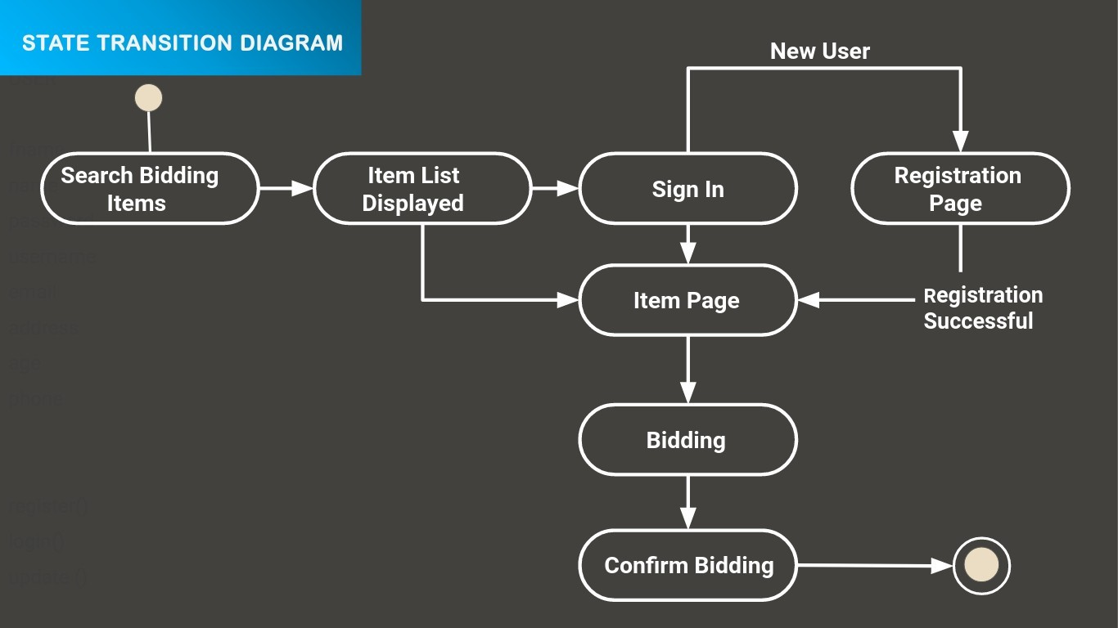

# BENEFITS

✔ It is easy and quick, and it can be done from the comfort of your chair at home.

✔ Time saving.

✔ System provides a flexible, simple way to spread information about auctions.

✔ there are no entry fees and other additional expenses.

✔ don’t have to go anywhere.

✔ the platform is easy to use, and everything is done on one website.

✔ Online auctions can be a bit less tense, so you will likely spend less money.

# DRAWBACKS

✗ shopping online is fun and addictive. Everything is virtual, so you can easily spend a lot more than you intended.

✗ You don’t get to inspect the item you are bidding for.

✗ as anyone can attend the auction, it means you will have to outbid a lot more people. And that becomes harder as the number of bidders goes up.

✗A website may go down for multiple reasons.

# Limitations

✗ Security risk posed by threat vectors.

✗ Price is often the major driving force.

# USER INTERFACE DESIGN MENUS

* **Home Page User Interface:**



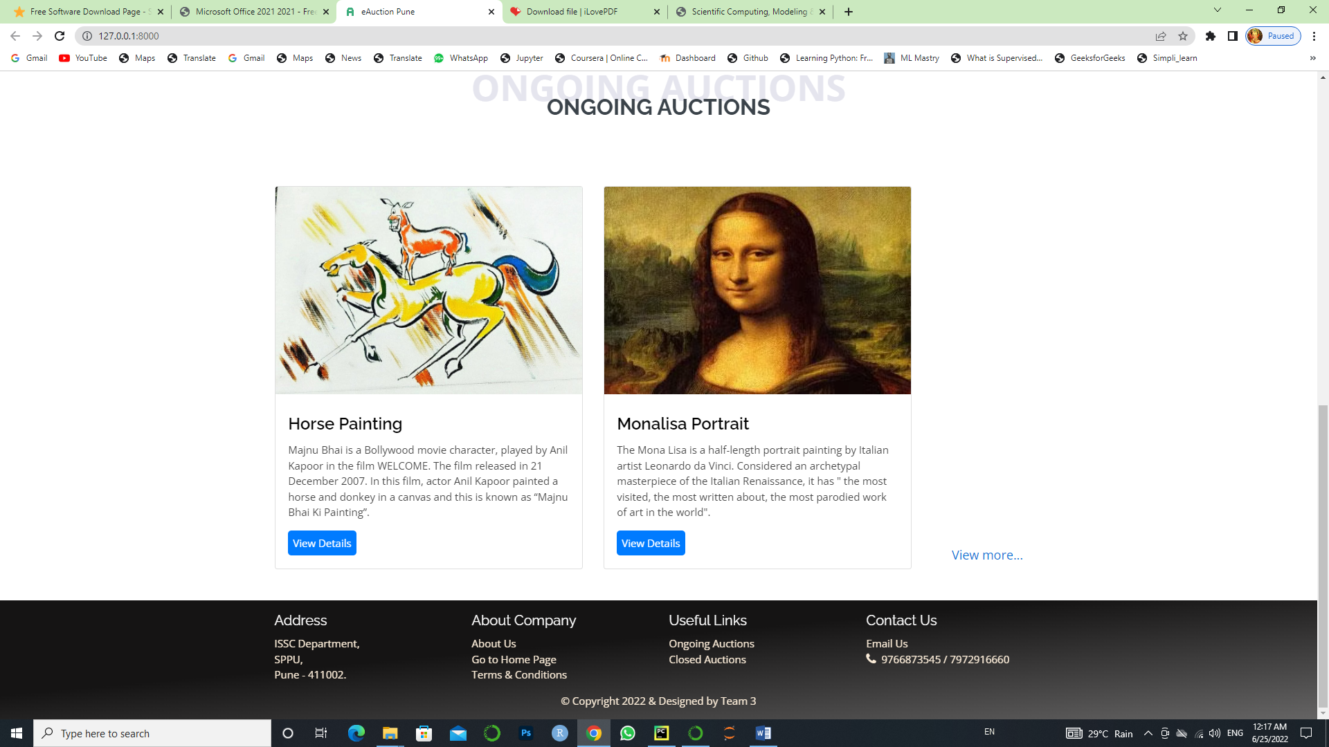

* **About Page User Interface:**



* 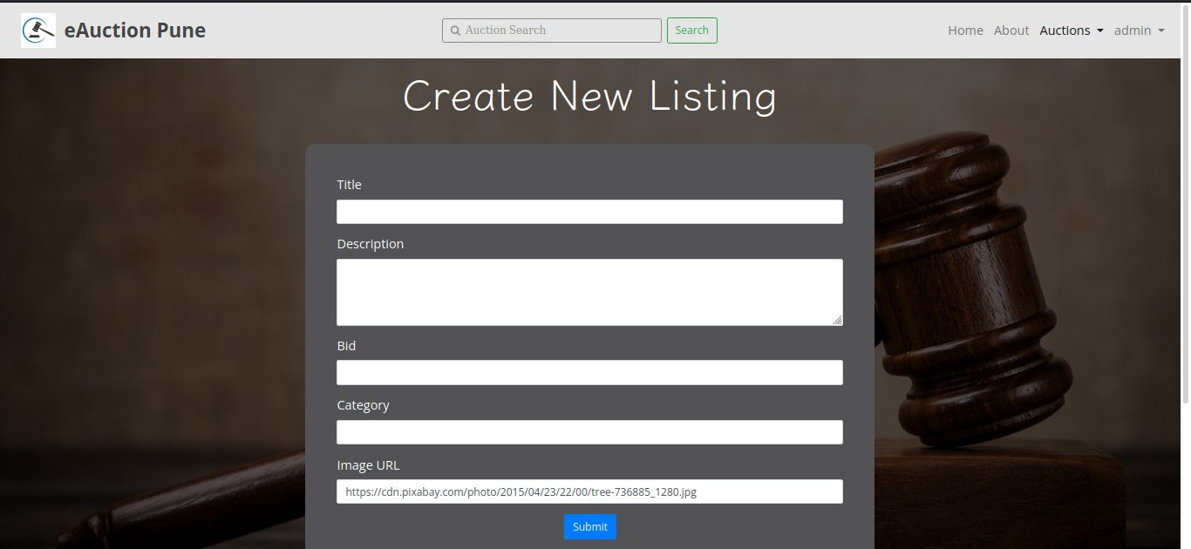**Create New Listing Form User Interface:**
* **Registration Form User Interface:**

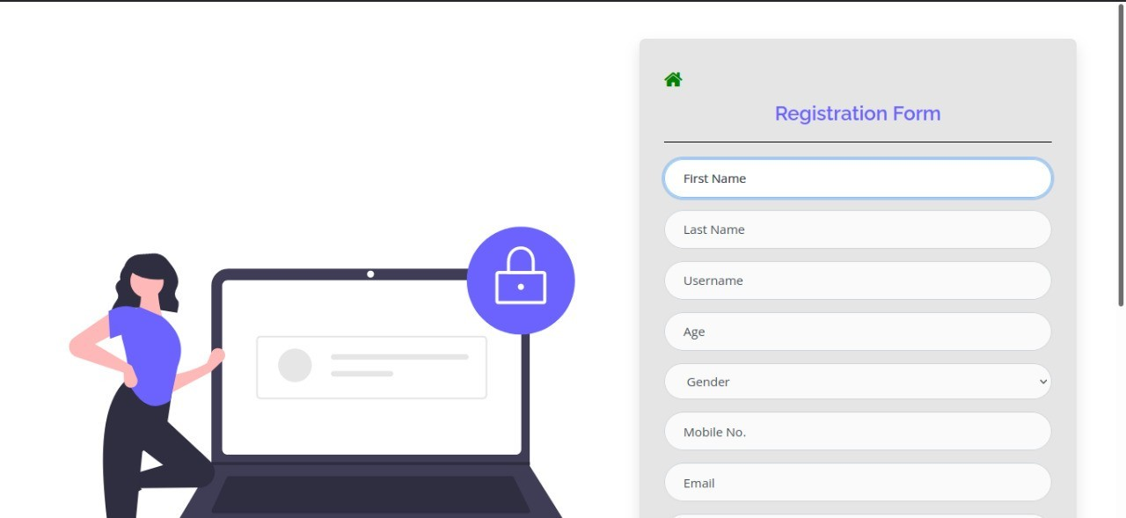



* **Login Form User Interface:**
* **Ongoing Auctions Page User Interface:**

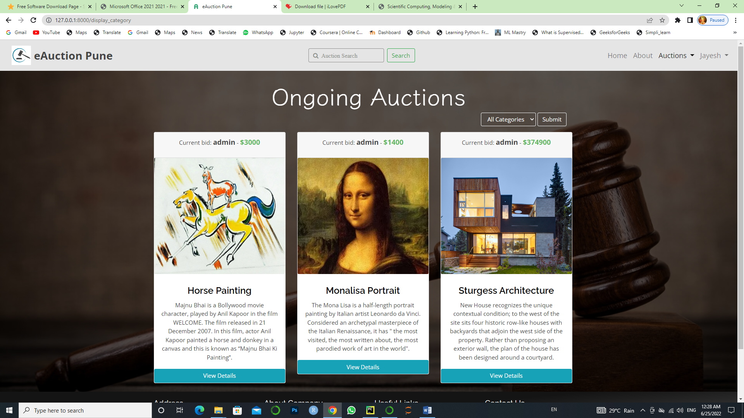

* **Closed Auctions Page User Interface:**



* **Search Result Page User Interface:**

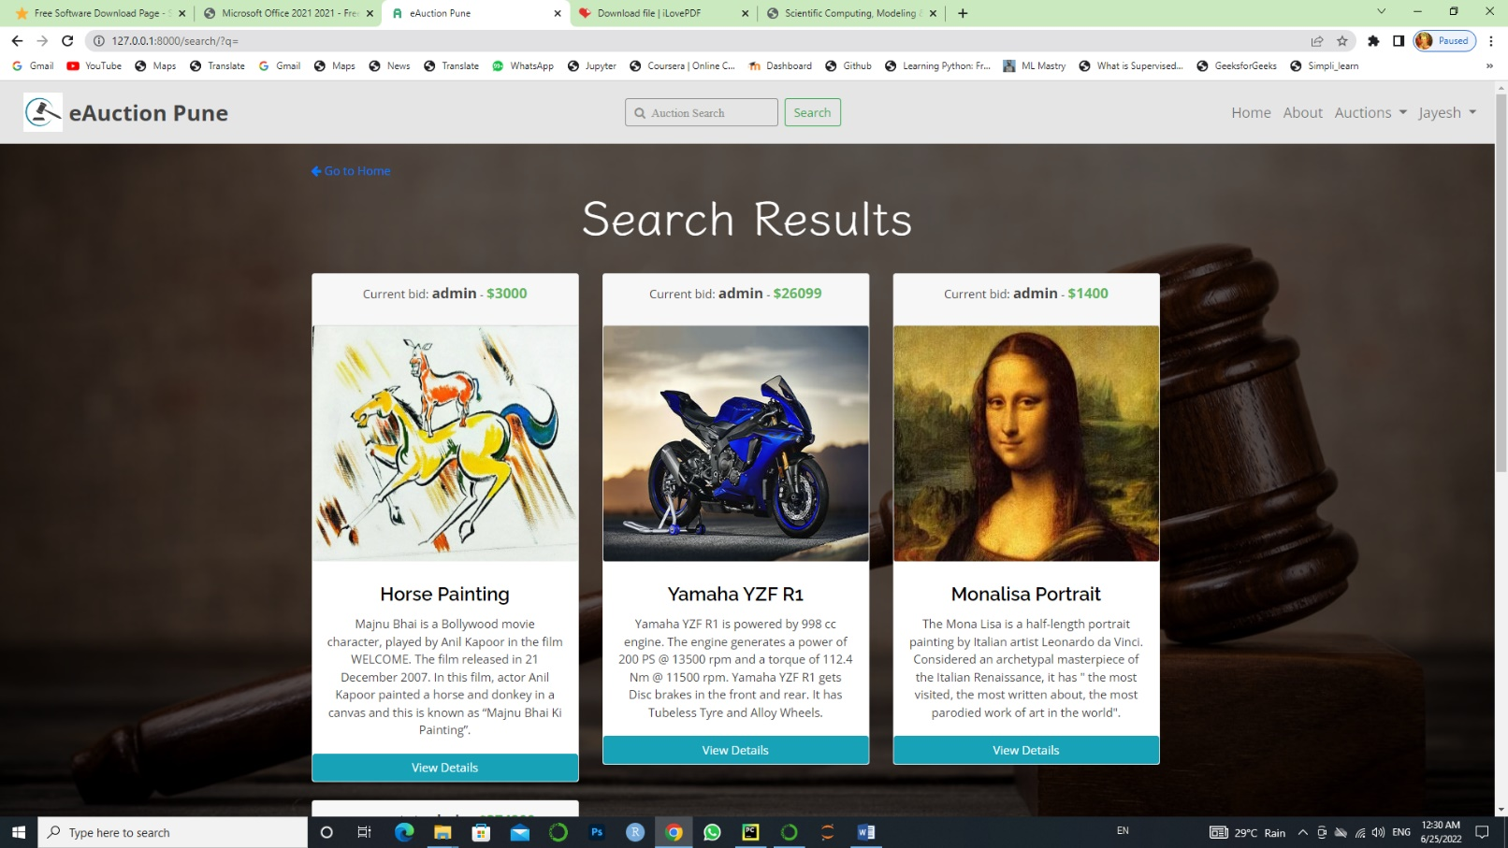

* 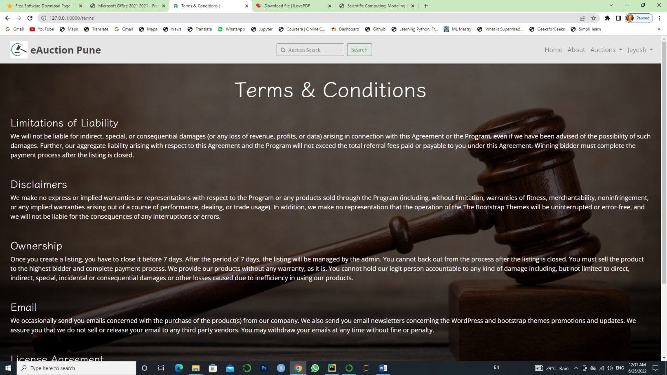Terms & Conditions Tab **User Interface:**
* **My Profile Page User Interface:**

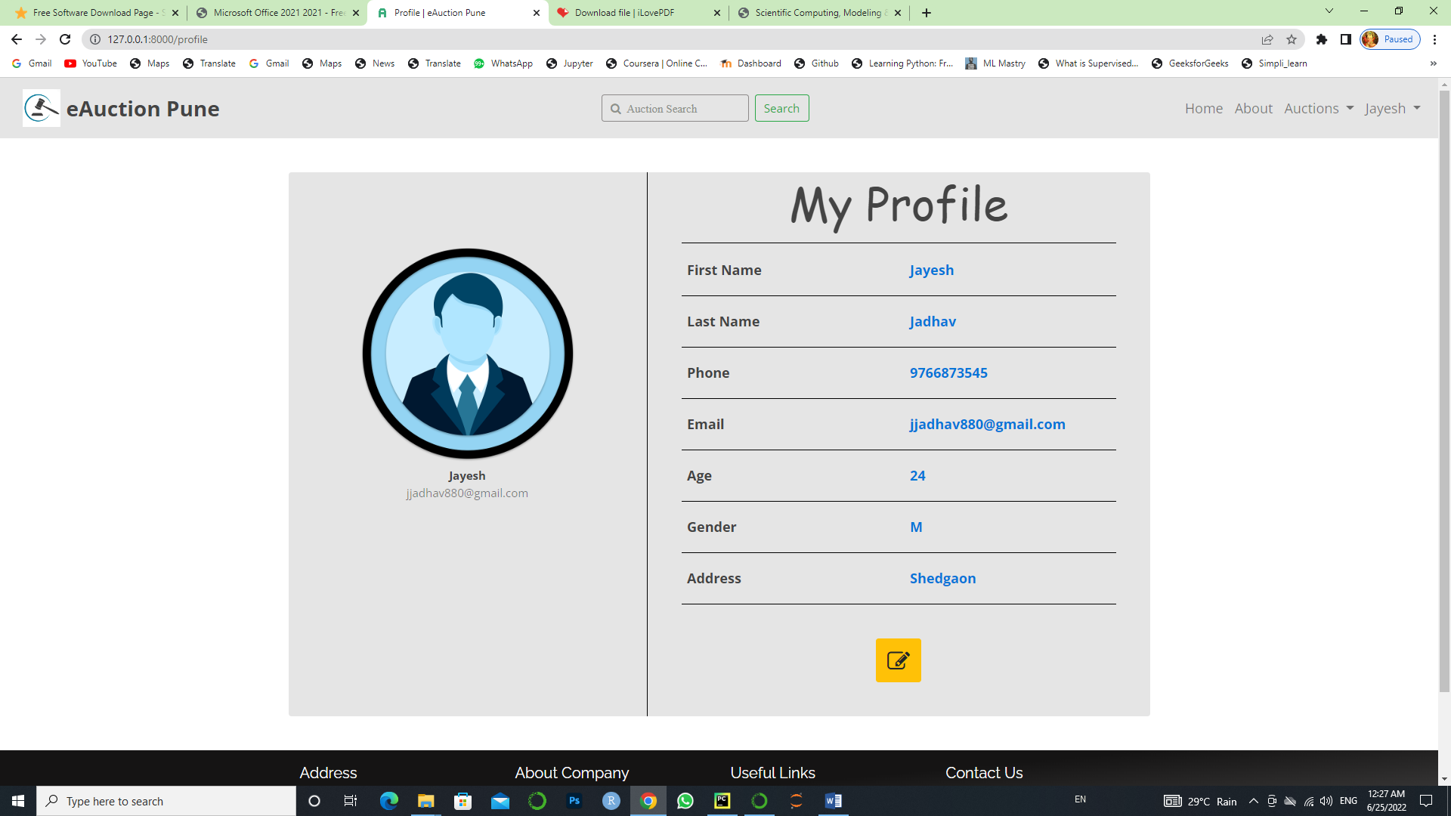

* **Add to watchlist feature User Interface:**



BIBLIOGRAPHY

* https://eauction.gov.in/eauction/
* https://[www.ebay.com/](http://www.ebay.com/)
* https://docs.djangoproject.com/en/3.2/